NEWS RELEASE
Media Contact:
Amanda Allwood
404-897-2277
Amanda.Allwood@CMG.com

KISS 104.1 to host 1st Annual One Joyous Night Gospel Concert
Starring Hezekiah Walker

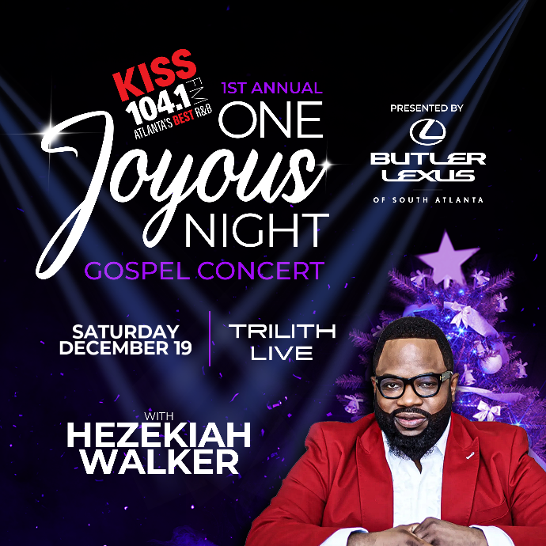
ATLANTA, GA – September 14, 2026 – KISS 104.1 (WALR / Atlanta, GA) is proud to announce One Joyous Night with Hezekiah Walker, an unforgettable evening of gospel music, inspiration and celebration. The concert will take place on Saturday, December 19 at Trilith Live and feature a night of uplifting performances and special appearances hosted by KISS 104.1 personalities Toni Moore, Tony Sco, Monie Love, Ramona DeBreaux, and more.

Legendary gospel artist and Grammy Award winner Hezekiah Walker is one of the most influential voices in contemporary gospel music. Known for iconic songs and acclaimed albums including Hezekiah Walker & The Love Fellowship Crusade Choir, Walker has inspired audiences worldwide through his dynamic performances and uplifting message.

“One Joyous Night will be a celebration of faith, music and the joy that brings us together,” said Michael Saunders, Director of Branding and Programming. “With Hezekiah Walker in the house, get ready to praise, sing and be inspired. This event is the reason for the season”

KISS 104.1's One Joyous Night is part of a multi-market Cox Media Gorup tour that will also visit select Florida markets.

Tickets go on sale Friday, September 18, at 10 a.m. and will be available through Ticketmaster.

One Joyous Night is presented by Butler Lexus.

Trilith LIVE is a premier entertainment complex in south metro Atlanta. Anchored in Fayetteville, GA in the Town at Trilith, the 530,000-square-foot venue is designed to host it all, including concerts, performing arts, live audience productions, conventions, banquets, and more. It serves as a one-of-a-kind destination for creativity, performance, and community. Trilith Live is located at 175 Trilith Parkway, Fayetteville, GA 30214.

About Cox Media Group
CMG Media Corporation is an industry-leading media company with unparalleled brands, award-winning content, and exceptional team members. CMG provides valuable local and national journalism and entertainment content to the people and communities it serves. The company's businesses encompass 17 high-quality, market-leading television brands in 9 markets; 45 top-performing radio stations delivering multiple genres of content in 9 markets; and numerous streaming and digital platforms. CMG's TV portfolio includes multiple primary affiliates of ABC, CBS, FOX, NBC, Telemundo and MyNetworkTV, as well as several valuable news and independent stations. For more information about CMG, visit www.coxmediagroup.com.

###

